Glossary  
Cybersecurity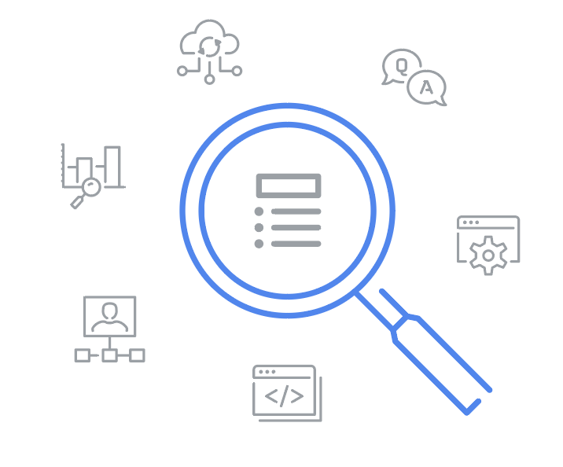

## Terms and definitions from Course 8

B

**Business continuity plan**: A document that outlines the procedures to sustain business operations during and after a significant disruption

C

**Confidential data:** Data that often has limits on the number of people who have access to it

D

**Data controller:** A person that determines the procedure and purpose for processing data

**Data processor:** A person that is responsible for processing data on behalf of the data controller

**Data protection officer (DPO):** An individual that is responsible for monitoring the compliance of an organization's data protection procedures

E

**Escalation policy:** A set of actions that outlines who should be notified when an incident alert occurs and how that incident should be handled

I

**Improper usage:** An incident type that occurs when an employee of an organization violates the organization’s acceptable use policies

**Incident escalation**: The process of identifying a potential security incident, triaging it, and handing it off to a more experienced team member

M

**Malware infection**: An incident type that occurs when malicious software designed to disrupt a system infiltrates an organization’s computers or network

O

**OWASP Top 10:** A globally recognized standard awareness document that lists the top 10 most critical security risks to web applications

P

**Private data**: Information that should be kept from the public

**Public data**: Data that is already accessible to the public and poses a minimal risk to the organization if viewed or shared by others

S

**Security mindset:** The ability to evaluate risk and constantly seek out and identify the potential or actual breach of a system, an application, or data

**Sensitive data**: A type of data that includes personally identifiable information (PII), sensitive personally identifiable information (SPII), or protected health information (PHI)

**Stakeholder:** An individual or a group that has an interest in any decision or activity of an organization

U

**Unauthorized access:** An incident type that occurs when an individual gains digital or physical access to a system or an application without permission

V

**Visual dashboard:** A way of displaying various types of data quickly in one place